Asgn-2: Eval of LTE Handover Algorithms

Graph-1: REM Plot of given 8-cell topology

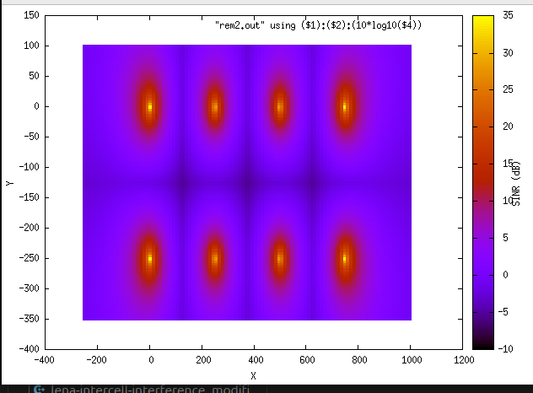

Analysis: we can see here the required 8 cell topology with SINR values falling with distance from the eNB.

Graph-2: Identification of a UE which has experienced a maximum number of handovers (using A3RsrpHandoverAlgorithm).

We fixed RngRun=4, speed=50m/s and observed which UE had the maximum number of handovers. To do this, we used a global array ueHandoverCount in the asg2.cc program indexed by the IMSI of the UE minus 1 (i.e., UE with IMSI 1 has its number of handovers stored in index 0, and so on). Entries of this array are incremented whenever NotifyHandoverEndOkUe is called.

UE with IMSI 6 was identified as having the maximum number of handovers (=3).

Rsrp plots of UE6 with speeds(10m/s, 50m/s, 100m/s, seed fixed at 4).

Speed = 10m/s:
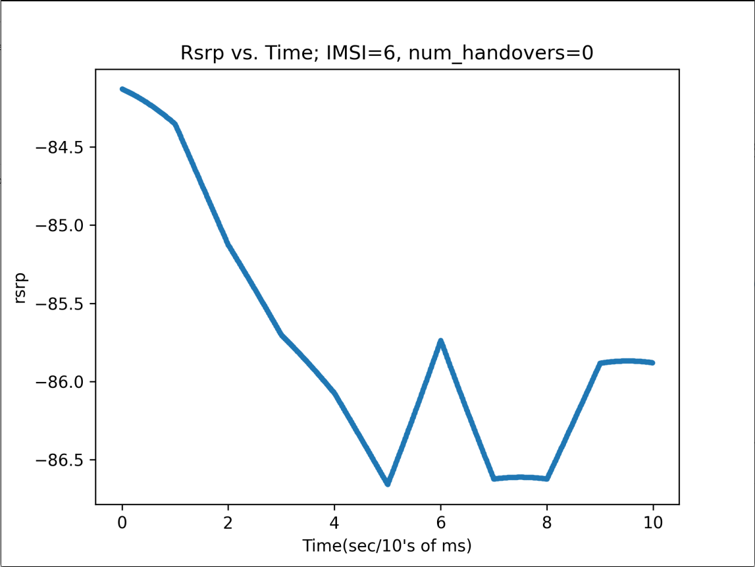

Speed = 50m/s:
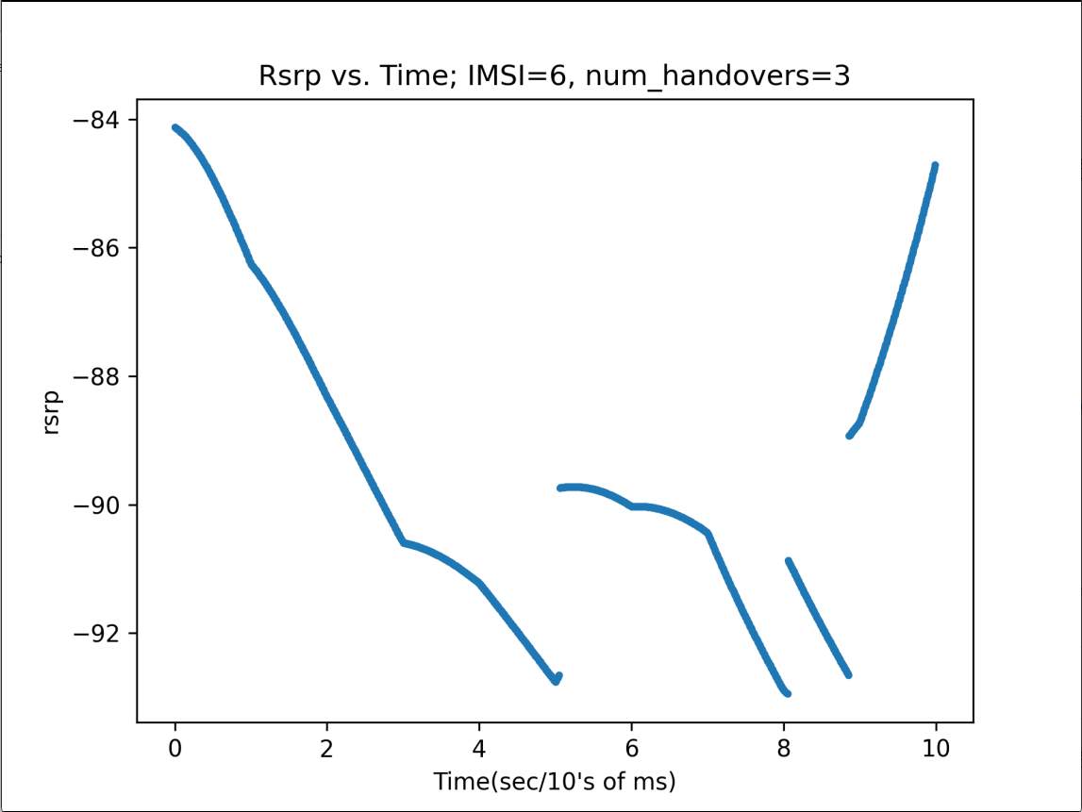

Speed = 100m/s:
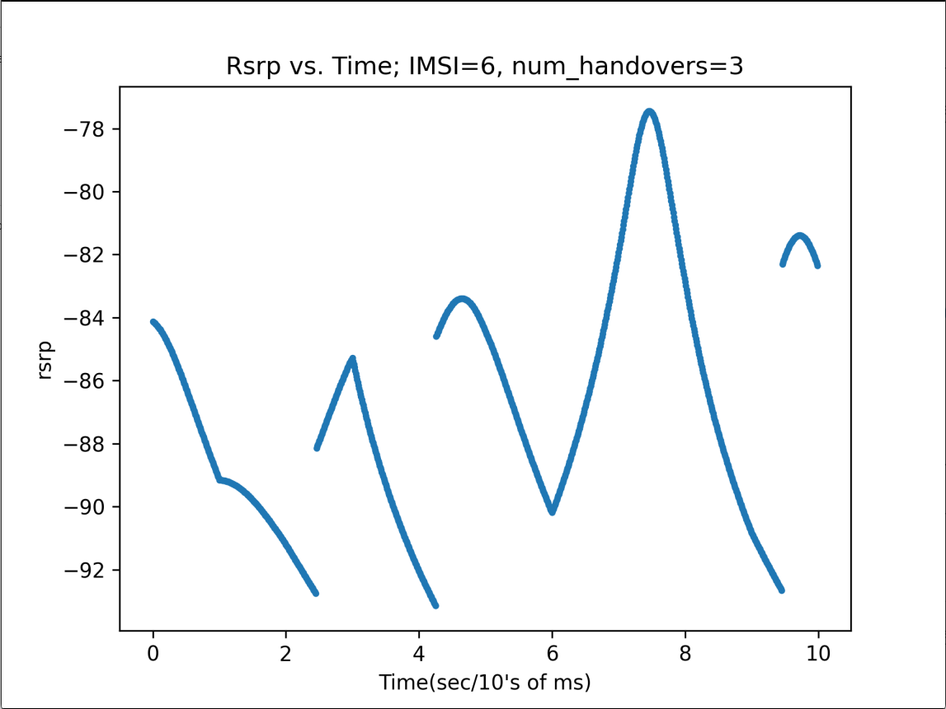

Time instants at which handovers took place:

For 10m/s: No handovers occurred.
For 50m/s: Handovers occurred at t=5s, t=8s, t=9s (sharp jump in rsrp)
For 100m/s: Handovers occurred at t=2.5s(approx), t=4.1s(approx), t=9.7s(approx) (see from graph)

Graph-3: Instantaneous throughput trace for UE6 at different times
Tput calculated every 0.05 seconds (using data from DlPdcpStats RxBytes).

Speed=10m/s:

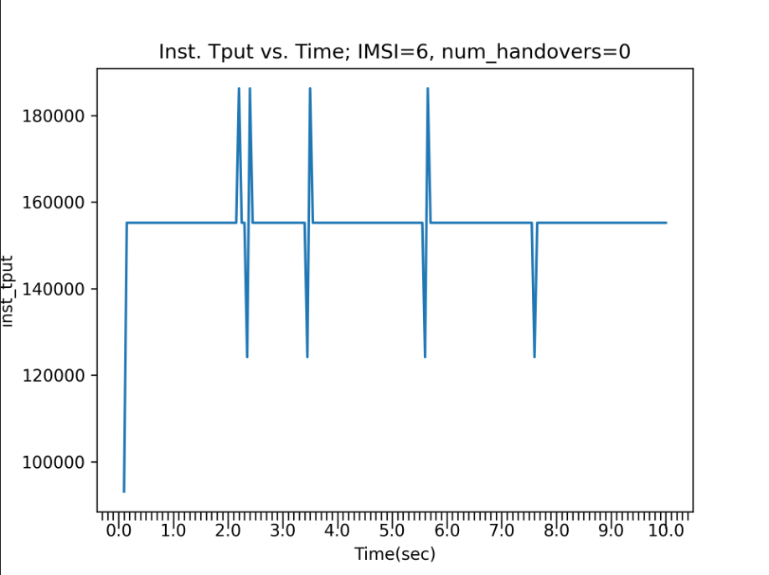

Speed=50m/s:
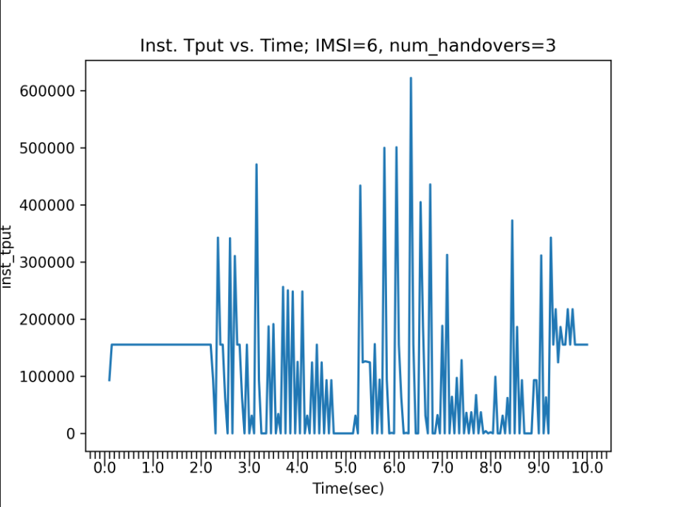

Speed=100m/s:
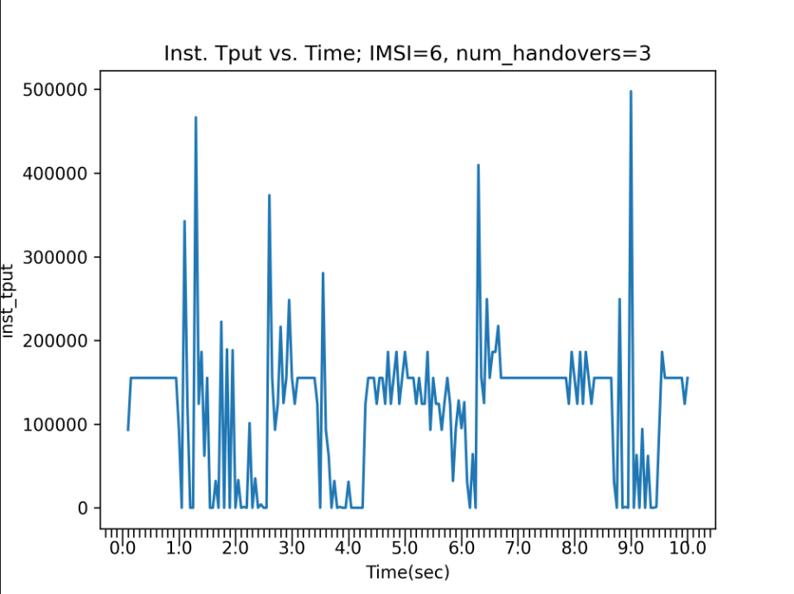

Analysis of the instantaneous throughput plots: at lower speeds (10m/s), tput mostly remains constant, but may go up or down depending on distance from eNodeB.
At higher speeds(50m/s, 100m/s), tput fluctuates a lot more due to UE entering and leaving coverage areas of different cells.

Graph-4: Effect of hysteresis on A3 Rsrp Handover algorithm

Speed=10m/s: (No handover. So all bars are 0)
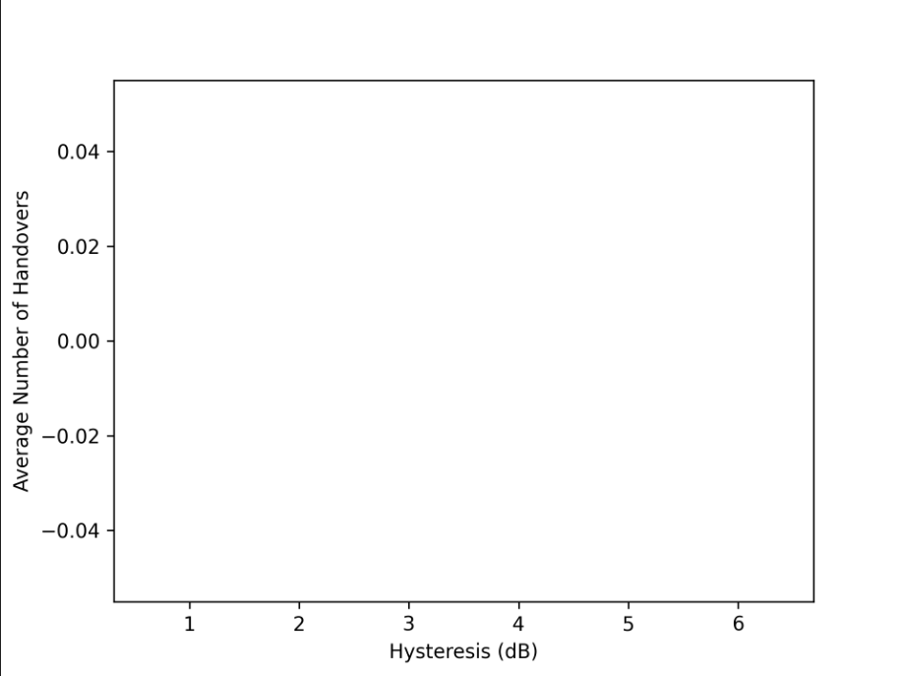

Speed=50m/s:
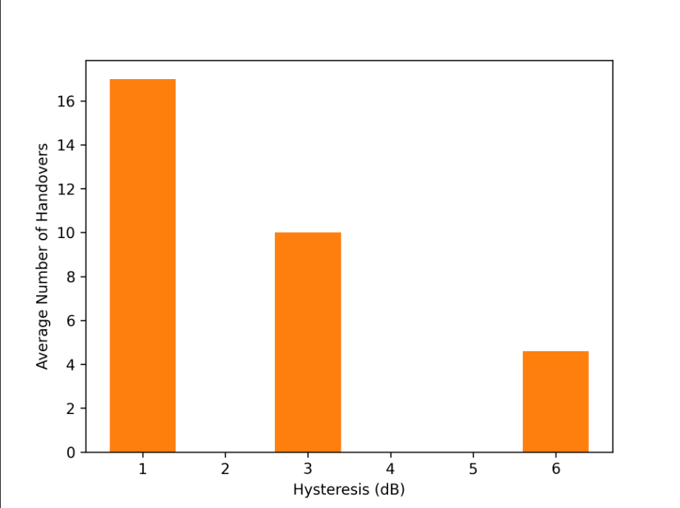

Speed=100m/s:
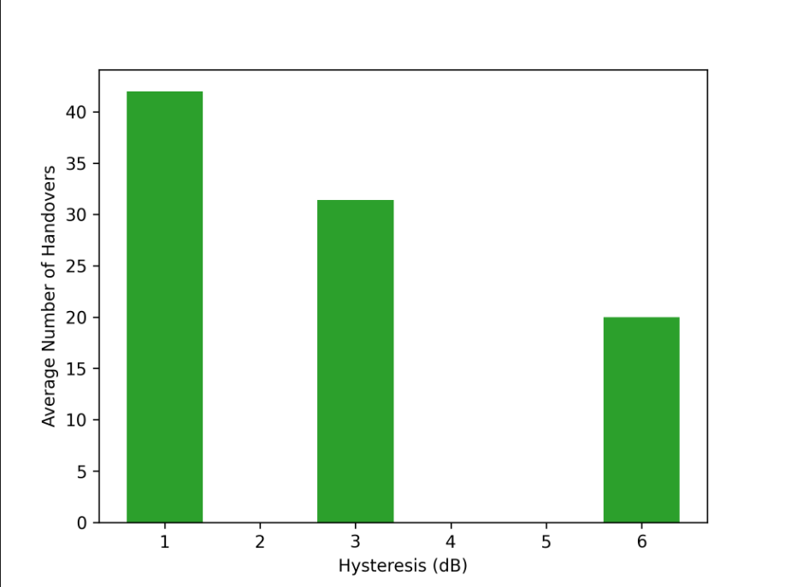

Does increase in Hysteresis lead to any handover failures?
Ans: Yes. With increase in hysteresis, there is more handover failure as can be seen from the decreased average number of handovers in the above plots.

What could you set as a good value for Hysteresis?
Ans: A good value for Hysteresis can be 3dB because it is neither too sensitive to RSRP changes (causing high signaling overhead) nor too robust (causing association with a weaker cell).

Graph-5: Effect of neighbour cell offset on A2-A4-RSRQ Handover Algorithm

Speed=10m/s (No handovers. So all bars are zero):

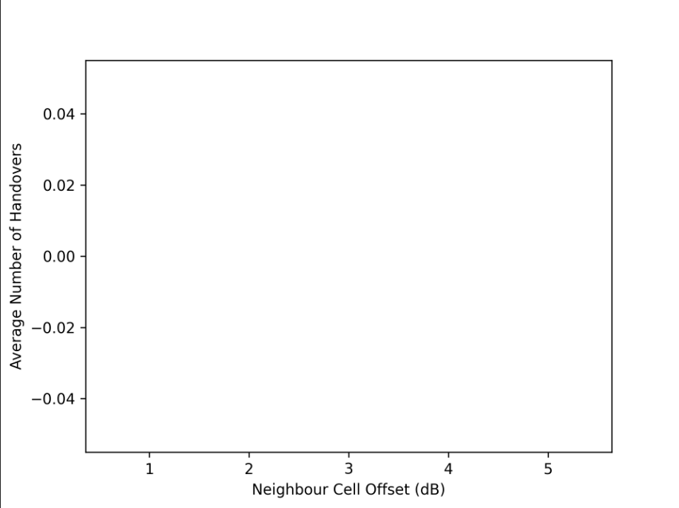

Speed=50m/s:
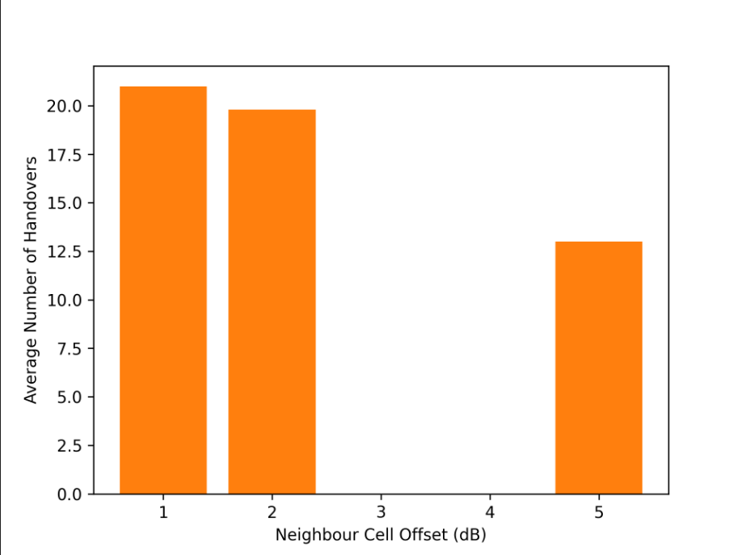

Speed=100m/s:
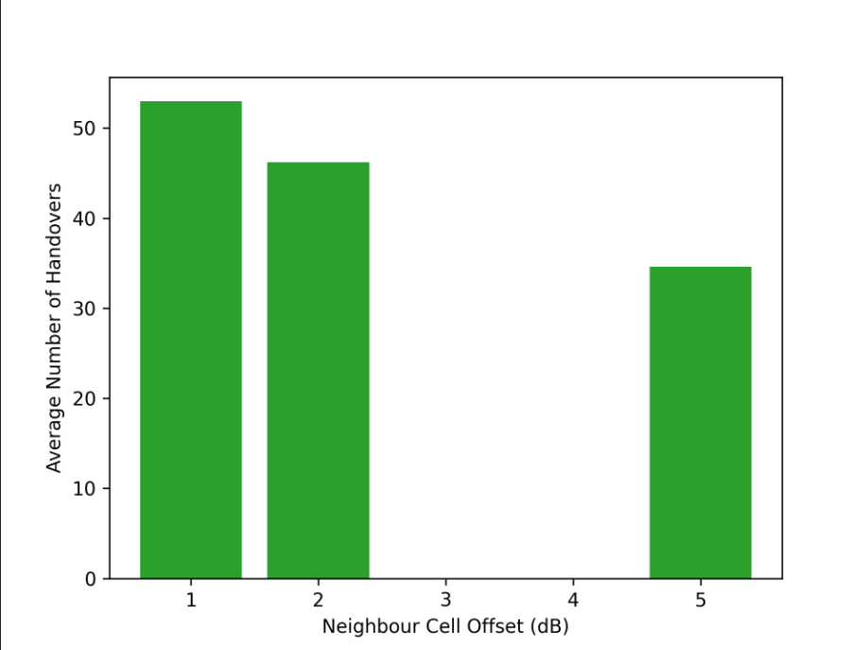

Does increase in Offset lead to any handover failures?
Ans: As neighbour cell offset increases, the number of handover failures goes up as can be seen from the graphs above

What could you set as a good value for Offset?
Ans: 2dB is a good tradeoff between sensitive handovers (high signaling overhead) and excessively robust handovers (staying connected to weaker eNodeB).

Graph-6: Plot Aggregate System Throughputs for different Handover Algorithms

NoOp Handover Algorithm:

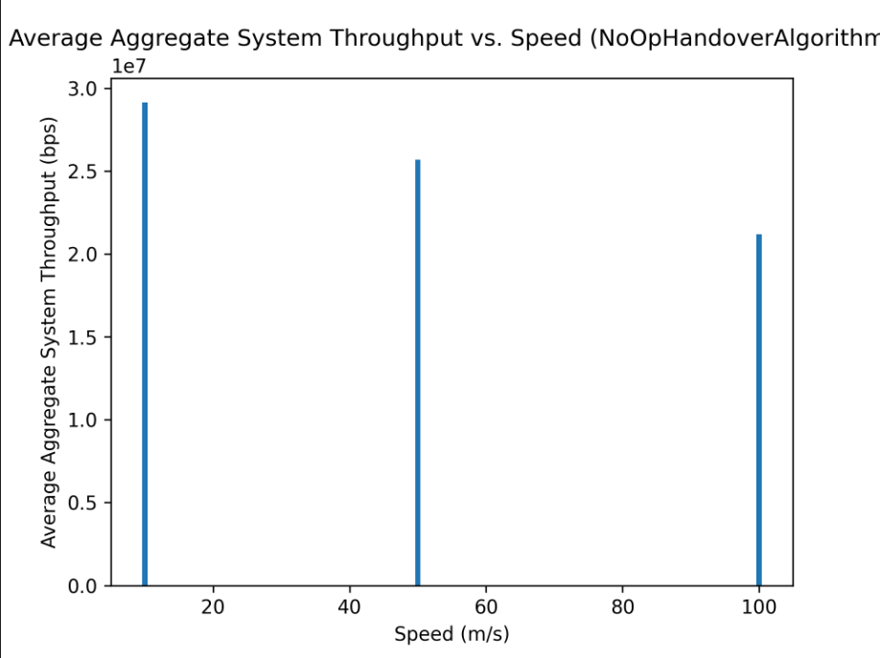

A3 RSRP Handover Algorithm:

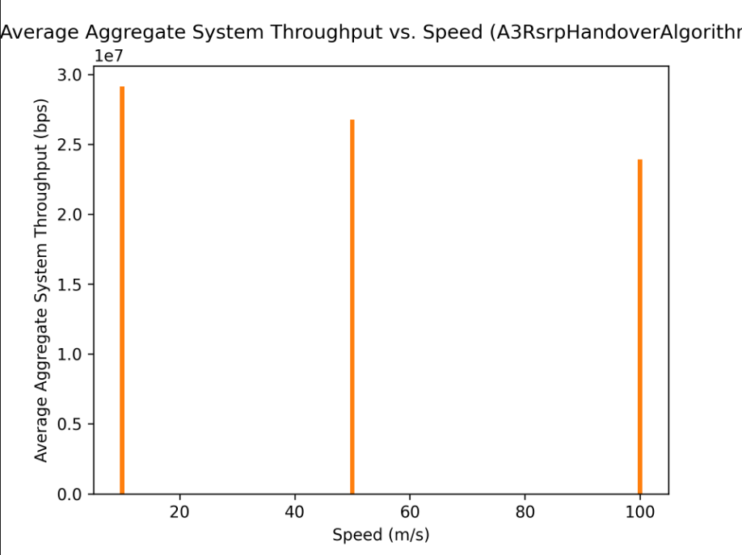

A2A4RSRQ Handover Algorithm:

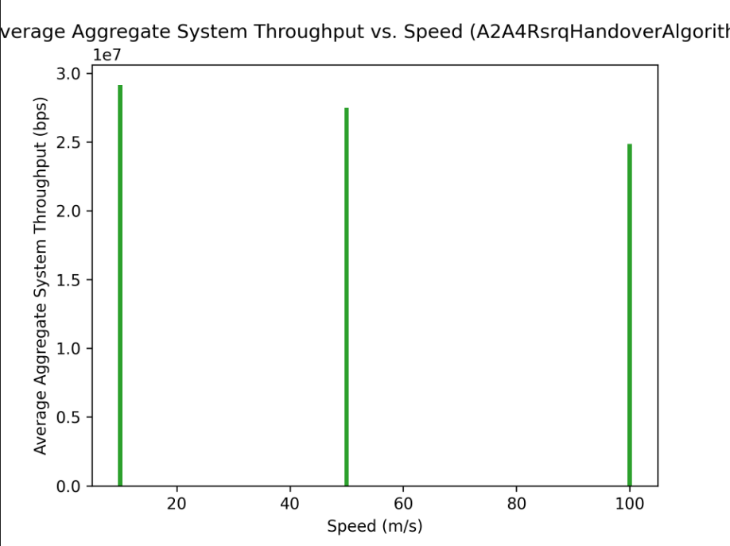
Provide analysis of the trends observed and quantify improvements for the scheduling/handover algorithms studied using the best Hysteresis and Offset value:

Ans: Best hysteresis value = 3dB and best offset value = 2dB.
All of this is observed from the plots (kindly see the submitted .png files for higher resolution plots).
At 10m/s, no handovers take place so we see that the avg aggregate tput is almost the same using all algorithms.
At 50m/s, both A3Rsrp and A2A4Rsrq give higher average aggregate system throughput than NoOp.
At 100m/s, we get the same conclusion. Both A3Rsrp and A2A4Rsrq give much higher average aggregate system throughput than NoOp.

Conclusion: Handover algorithms significantly help increase the average aggregate throughput of a cellular system.

TCP Bonus Task

Graph-1: TCP Throughput vs. Time

Speed=10m/s
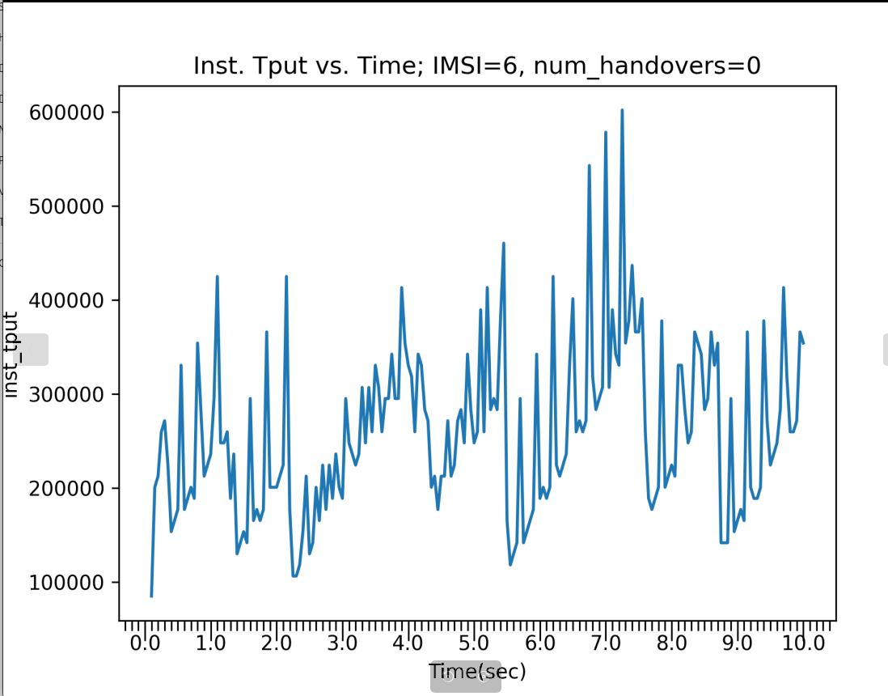

Speed=50m/s
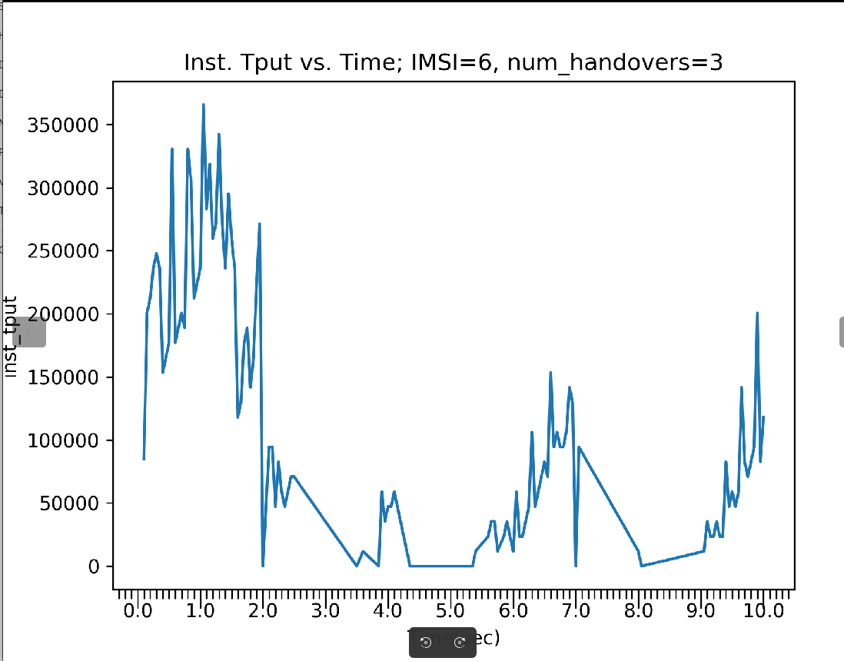

Speed=100m/s
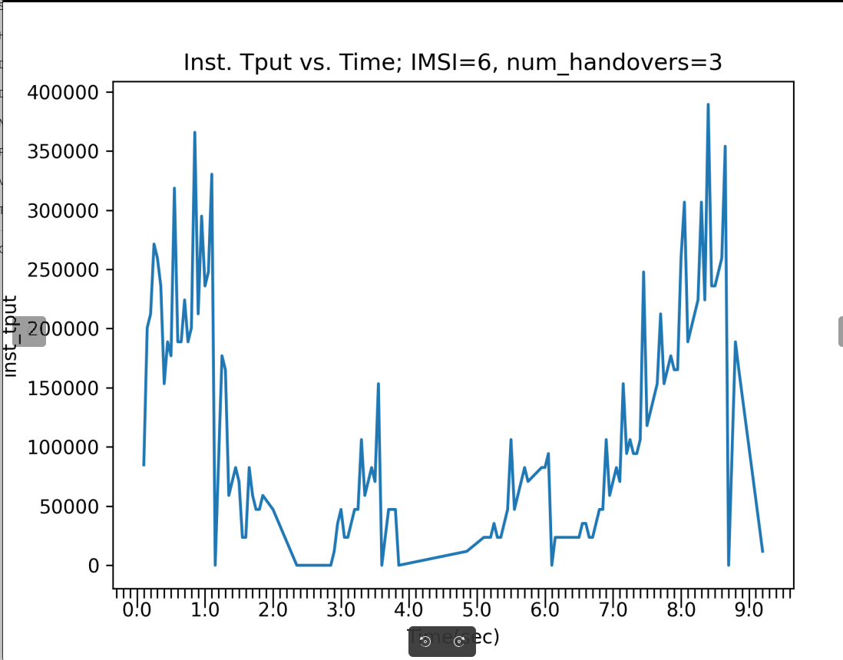

Compare against UDP throughput in the original assignment:
At all speeds, we observe that:
- TCP throughputs follow a pattern similar to their cwnd changes (kindly see the plots below as well), i.e., they are reflective of the congestion window behaviour at the sender.
- UDP throughputs are mostly flat, with numerous spikes and drops in throughput, this is because of the absence of any congestion control mechanism and the unreliable nature of UDP transport.

Graph-2: TCP Congestion Window (CWND) vs. Time

Speed=10m/s
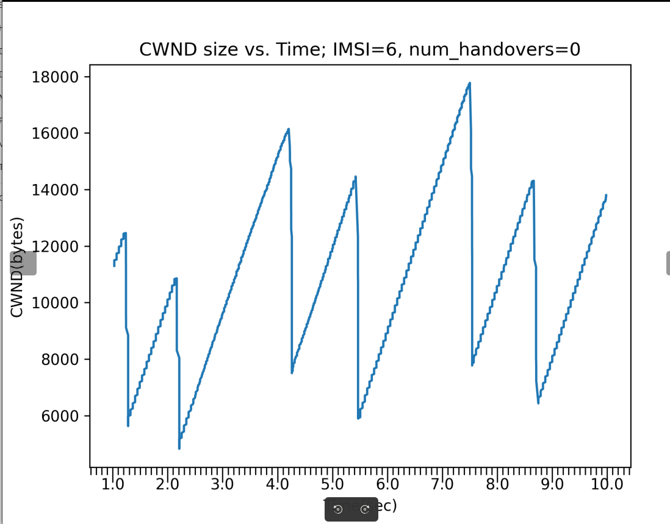

Speed=50m/s:
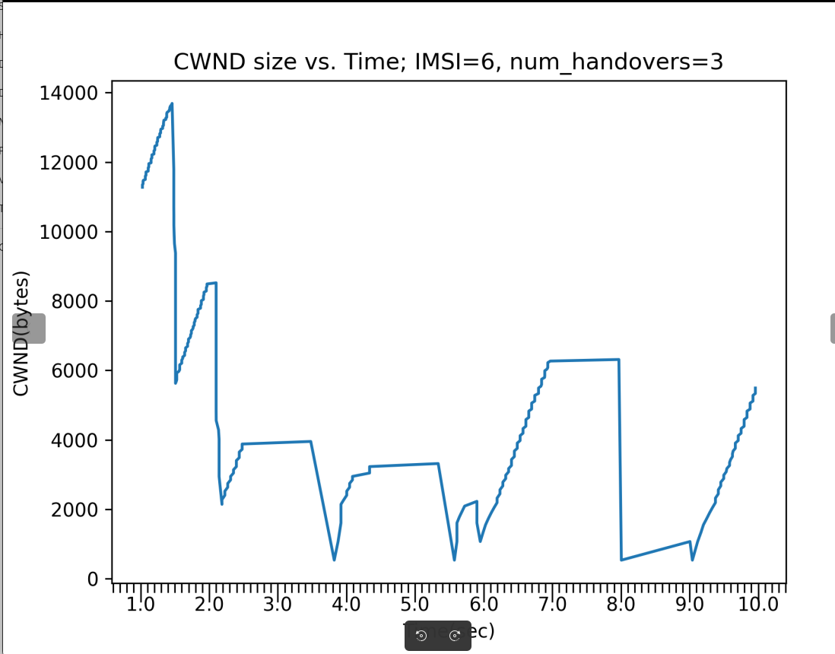

Speed=100m/s
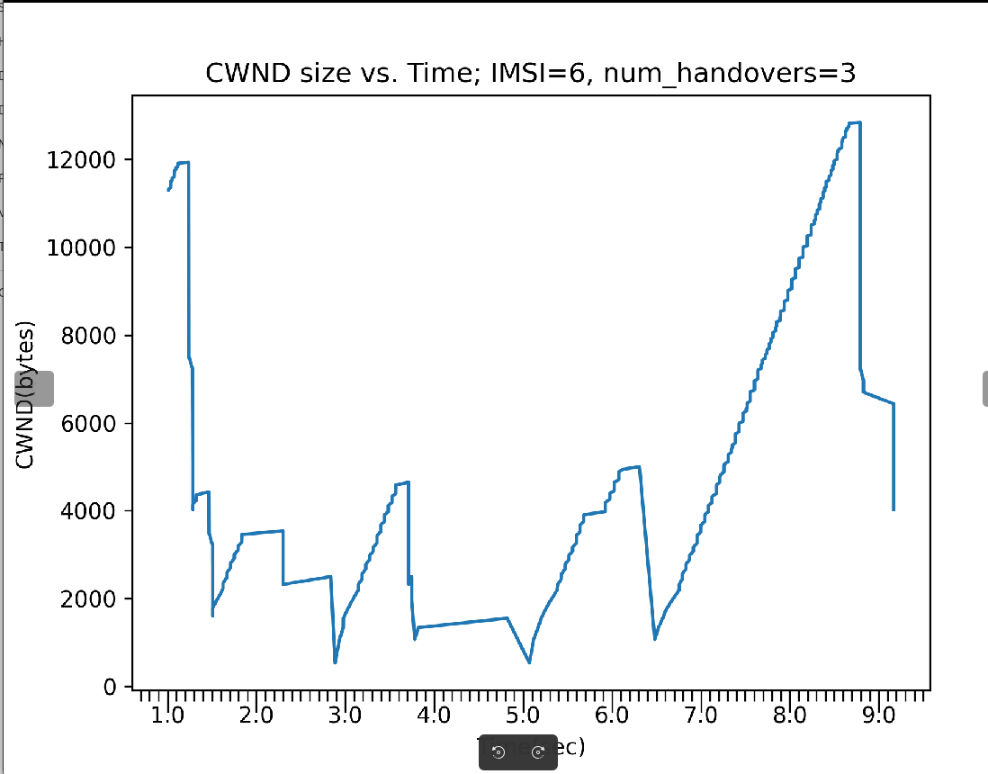

Question 1: Does TCP experience a throughput drop during handovers?
Answer: Yes. From Graph1 above of instantaneous throughput, when speed =10m/s and there is no handover, the maximum instantaneous throughput is 600,000 bytes/sec and the average is around 350,000 bytes/sec. But from Graphs of speed=50m/s and 100m/s we see that the maximum is 350,000-400,000 bytes/sec and the average is even lower.

Question 2: How does congestion control behave (e.g. slow start, fast retransmit)?
Answer: From Graph2, first plot (speed=10m/s, no handovers), we see the standard AIMD sawtooth, suggesting the sender is in congestion avoidance phase. But in the presence of handovers (other two graphs, speeds=50m/s and 100m/s), we see many instances where the congestion window drops to half its value e.g. at t=1.5s approx. in the second plot. This is the fast recovery state of TCP New Reno CA. Timeouts appear not to have occurred since, there are no cases where the congestion window suddenly drops to a very low value.
In the third plot, from around t=6.5s to t=8.5s, we see a rather long phase of congestion avoidance.

Question 3: Is TCP more resilient or does it suffer more than UDP during handovers?
Answer: TCP suffers more than UDP during handovers as can be seen from the throughput plots. We see that the UDP throughput is more stable, whereas TCP throughput varies a lot over time. This is because of the additional overhead of retransmission traffic.

Anti-Plagiarism Statement:

By submitting this assignment, we certify that the work presented here is our own, based on our personal research, observations, and understanding. We affirm that:
• All data, diagrams, and content used from external sources (e.g., blogs, articles, papers, videos, podcasts) have been appropriately cited and acknowledged in the report.
• Diagrams or visuals borrowed from online sources have been clearly credited, and I have provided my own explanations or insights for all included visuals.
• This assignment has not been copied in part or whole from any other student or individual, and I have not used pre-written solutions or responses generated by LLMs (e.g., ChatGPT) without significant personalization, verification, and adaptation.
• If I used any AI-based tools, I have appropriately acknowledged their usage and ensured that the work has been refined through my own understanding and knowledge.
• I understand that failure to adhere to these guidelines may result in penalties for academic misconduct, as outlined by the dept’s policies.

We also pledge to uphold the principles of honesty and integrity during this course and report any violations of the academic code of conduct if we become aware of them.

Names: Dhanraj Shrivastav <CS24MTECH11004>, Jayanth Jatavath<CS24MTECH11014>
Date: 13th April 2025
Signatures: DS, JJ

